Program Quality Review for Mathematics Department

R.Kumaresan, S.Kay

Department of Electrical and Computer Engineering

Kelley Hall

O.Merino

Department of Mathematics
Tyler Hall

Table of Contents

I . Description of the department

Mission Statement

- Programs

B.I Undergraduate Degree Programs in Mathematics

B.I.1 B.A.
B.I.2 B.S., General Program
B.I.3 B.S., Applied option

B.II Graduate Degree Programs in Mathematics

B.II.1 M.S.
B.II.2 Ph.D,
B.II.3 Ph.D, Applied Mathematical Sciences

C. People

C.I Faculty and Staff

C.II Students

C.II.1 Undergraduate enrollments
C.II.2 Undergraduate majors in Spring 2001
C.II.3 Enrollments by undergraduates at level of MTH 141
C.II.4 Graduate Enrollments

D. Facilities

- Teaching

E.I The Service Role

E.I.1 Undergraduate level

E.I.1.i) Reform Calculus
E.I.1.ii) Use of technology
E.I.1.iii) Modernization of precalculus
E.I.1.iv) General Education

E.I.2 Graduate level

E.II Programs for the Undergraduate Major

E.II.1 Masters Program
E.II.2 Doctoral Program

F. Research

G. Service

II. Evaluation

III. Recommendation

A.Computer Facilities

B. System Administrator

C. Space

D. Faculty Recruitment

- Improvement to Research Environment

Program Quality Review for Mathematics Department

I:Description of the department

Mathematics is a core area in the liberal arts. It is also fundamental to study in the physical, biological and social sciences, information technology, and engineering.
A vibrant Department of Mathematics is very important for achieving the mission of the university and prosperity of the state of Rhode Island.

A:Mission Statement

The interlocking aims of the Mathematics Department are to provide high quality, forward-looking instruction in mathematics for all students, at all levels; to encourage and develop the mathematical skills and talents of those undergraduates with a special intellectual and professional interest in mathematics; to train, at the graduate level, a corp of accomplished mathematical teacher/researchers; to advance the field of mathematics in our focused research areas; and to serve as a principal resource in mathematics for the University community.

B:Programs

I. Undergraduate Degree Programs in Mathematics

The department offers three bachelors degrees.

1. B.A. The Bachelor of Arts program is intended to present mathematics as one of the liberal arts. The requirements in mathematics are flexible. This degree is often obtained in a double major with (secondary) education.
2. B.S., General Program. This program is intended for students who are considering graduate study in mathematics. It stresses basic theory and technique.
3. B.S., Applied Option. This program emphasizes applications of mathematics while still offering a basic theoretical foundation. Many students find it possible to have double majors with other sciences, especially chemistry, physics, and computer science, and it is expected that new University guidelines for double majors there will result in more double majors with engineering.

II. Graduate Degree Programs in Mathematics

The department offers both masters and doctoral level programs.

1. M.S. The Masters program prepares students for work in industry, teaching at high school through beginning college level, and further study at the doctoral level.
2. Ph.D., The department's doctoral program provides basic training in mathematical research and prepares students for careers in college and university teaching as well as advanced work in industry.
3. Ph.D. Applied Mathematical Sciences The Mathematics Department is among a group of departments that sponsor a Ph.D. program in the mathematical sciences, including statistics, computer science, operations research and finance. All students in this program take some mathematics at the graduate level, and mathematics students in this program follow a course of study similar to the conventional Ph.D. but with greater interdisciplinary emphasis.

Most students in these graduate programs serve as Graduate Teaching Assistants. The department is committed to mentoring and supervising these teaching assistants so as to provide high-quality instruction for undergraduate students while affording graduate students valuable teaching experience.

C:People

I. Faculty and Staff

As of fall 2001 the Mathematics department has 16 permanent faculty members of which 4 are assistant professors, 2 are associate professors and 10 are full professors. Also, the department employs 3 lecturers. A number of per course instructors (between 5 and 15 in different semesters) teach as many as 20 sections in a given semester. 13 or 14 teaching assistants teach sections of lower division courses, conduct tutoring sessions in Learning Assistance Center, and hold office hours. The department also employs 2 secretaries.

II. Students

1.Undergraduate enrollments

Undergraduate enrollments in mathematics courses
 | 1997-1998 | 1998-1999 | 1999-2000 | 2000-2001
Fall | 2542 | 2599 | 2734 | 2653
Spring | 1597 | 1653 | 1833 | 1861
Total | 4139 | 4252 | 4567 | 4514

(The Notices of the American Mathematical Society (Sept. 2001, p. 825) gives the average ratio of undergraduate mathematics course enrollments to FTE mathematics positions at institutions comparable to ours as 119. The ratio at URI is 162. )

2. Undergraduate majors in Spring 2001: 66 (counting students registered in courses at least at MTH 141 level who have declared a mathematics major)
Spring 2000: 34
Spring 1999: 43
Spring 1998: 40
Fall 2000: 44
Fall 1999: 46
Fall 1998: 42
34 of the 66 undergraduate majors are women.
3. Enrollments by undergraduates at the level of MTH 141 and above by students who have declared a mathematics major
 | 1998-1999 | 1999-2000 | 2000-2001
Fall | 42 | 46 | 44
Spring | 43 | 34 | 66

4.Graduate enrollments
15 fulltime and 11 part time graduate students are enrolled as of Fall 2001. 9 of the fulltime students are women. 5 students received MS degrees and 3 students received PhD degrees in May 2001.

D:Facilities

The Mathematics Department is housed in Tyler Hall in the Kingston Campus. In this building the department has the following facilities.

1. Classroom space
1 classroom, Tyler 106

2. Lab space
1 very small lab with 4 old computers and printer for graduate students
1 small lab (new) with 16 computers for undergraduates

3. Office space
Faculty and lecturers have individual offices.
Per course instructors and teaching assistants share offices.
4. Other

There is a department conference room but there are no usable gathering spaces for students, or faculty, to interact informally in a convenient way.

E:Teaching

I. The Service Role

1. Undergraduate level

The department is well aware of its crucial role in students' ability to pursue their chosen majors and careers. It has kept abreast of developments in mathematics pedagogy at the college level the following ways. The department maintains an active web site and all faculty are encouraged to make course material available to the students via this website. This includes reference material, Maple assignments, course syllabi, etc.

i) Reform calculus. Starting in the early 1990's the department has evolved a moderate approach to calculus reform, a movement during the last decade to revamp calculus instruction. The calculus reform movement was heavily promoted by the National Science Foundation and members of the department received substantial funding for work in developing and extending materials and approaches within this initiative and popularizing at institutions across the state. The reform approach aims to present calculus in a way that stresses basic concepts by exploring them in visual, numerical and verbal ways, as well as through traditional algebraic manipulations, and helps students to make effective use of the subject in other disciplines.

ii) Use of technology. Starting in the late 1960's, the mathematics department has taken a special interest in the use of technology for calculus instruction. John Fraleigh was one of the pioneer users of the BASIC computer language in calculus instruction, and the department offered a 1 credit supplement in computer calculus to the basic calculus course. It has continued to develop computer materials for calculus, lately with funding from the Rhode Island Board of Governors for Higher Education (RIBGHE). These materials make use of powerful computer algebra systems like Maple and require students to hand in small and moderate size projects. The department has also started to use web-based quizzing and homework as well as an assortment of special purpose software tools in subjects ranging from MTH 108 (a liberal arts course) to graduate courses.

iii) Modernization of precalculus. In the last year the department has begun a revision of precalculus to make more extensive use of appropriate technology both for tutorial purposes and for quizzing. Development is underway to use up-to-date multimedia techniques for this as well as more traditional approaches. A high speed server to handle the increased load due to these projects has been installed.

iv) General Education. The department is committed to its role in providing general education courses in mathematics and enrollments in courses specifically designed for general education (MTH 107, 108) accounted for about 20% of mathematics enrollments in Fall 2001. There is certainly an significant additional percentage of general education enrollments in precalculus and calculus. Several faculty members have special interest in the general education offerings in the department and have authored textbooks and innovative software to be used in these courses. The department is in the process of revising general education courses in line with new University requirements.

2. Graduate level

The department has a significant service role at the graduate level. Graduate students in other fields (physics, engineering, computer science, oceanography, economics) take application oriented graduate courses in such areas as numerical analysis, probability theory, and mathematical statistics, as well as core courses in mathematics at the graduate level.

The department has been a resource for local industries and has long-standing ties to ocean science and Navy agencies and industries in the area.

II. Programs for the Undergraduate Major

The goal of the undergraduate major programs is to equip students with a body of basic mathematical knowledge, together with the problem-solving skills to put that knowledge to productive use. These programs should provide a foundation for further study in mathematical sciences, and for careers in which creative problem solving and quantitative reasoning, sometimes of a general nature, are highly valued.

The department has increasingly encouraged double majors with disciplines such as computer science, chemistry and physics, which have traditionally involved substantial mathematics, as well as education and social sciences like economics. With the recent change in University rules the department expects to see a number of double majors with engineering disciplines in the near future.

Reform calculus instruction and use of technology (discussed above in connection with the department's service role) are especially valuable for beginning students concentrating in mathematics. Moreover, the department is modernizing the content of many advanced courses, especially in greater emphasis on discrete mathematics and the incorporation of advanced computing tools, such as computer algebra and visualization systems.

II. Masters Program

The Master’s program emphasizes core mathematics. Although there is a thesis option, most students elect the non-thesis option that involves them in more coursework. A one-credit major paper is required.

Master’s graduates have gone on to further graduate work elsewhere, continued here, found jobs in industry or in high school, community college or college teaching. Teaching assistants get extensive experience in the classroom, and lots of mentoring, resulting in high teaching competence.

- Doctoral program

The two doctoral programs involve substantial coursework beyond the Master’s level and significant accomplishment in mathematical research, resulting in publishable work. In the last few years the department has produced about 3 mathematics Ph.D. graduates per year.

Students have been very successful in the appropriate academic and industrial job markets. As with Masters, teaching experience is high quality and has made students very employable. They have become regular faculty at Rhode Island College, Providence College, Merrimack College, Virginia Commonwealth University, Rochester Institute of Technology, Murray State University, University of Michigan (Dearborn), Fitchburg State University among others. Many students have been employed by Navy-related industries in the area, others in the high technology industries in other parts of New England.

Research areas in the department generally have an applied orientation and are relatively accessible, also aiding employability of graduates.

F:Research

The Mathematics Department has research focus areas in the fields of Difference Equations/Discrete Dynamical Systems, Combinatorics and Graph Theory, and Applied Analysis. Each of these fields has a core of fundamental mathematics and a significant range of applicability. Both dimensions of these areas are pursued by researchers in the Department. Difference equations and discrete dynamical systems, for example, are objects of much theoretical study, but are also used extensively to model and solve problems in population biology. The applied analysis areas stem from classical mathematics but have applications in signal processing, control of systems, and modeling the flow of fluids.

The Journal of Difference Equations and Applications is co-edited in the department and the department has national leadership stature in this field. See the attached annual reports for a listing of recent books, journal articles and conference presentations by member of the mathematics faculty.

Members of the mathematics faculty have received grant funding at a rate comparable to that other New England state universities of comparable size (UNH, UVM, UMaine). Last year there was 1 NSF (Liu) and currently there is 1 NSF (Thoma) funded grant. Several faculty members also have been consistently funded by the Rhode Island Board of Governors Excellence in Technology programs and one faculty member is part of a large umbrella grant from NIH.

The department holds weekly department seminars in difference equations and combinatorics and less frequent seminars in applied analysis. These seminars feature talks by faculty and graduate students. Although the department does not hold a regular colloquium series as in the past, occasionally series of talks by well known speakers are sponsored.

G: Service

1.Outreach Activities.
Faculty (Prof.Merino) have been active with the SMILE (Science and Math in Learning Experience) program. With the departments encouragement and support several enthusiastic and capable graduate students have run a math camp for school age chpldren in the state. This has been an ongoing program for three years.

2.Interaction with High Schools.
The mathematics department has had many formal and informal contacts with high school teachers in the state over many years. Professors Datta, Eaton and Finizio have run in-service courses in calculus and discrete math for high school teachers. Professor Eaton has run American Mathematics Contests for the schools in the state. Professor Pakula headed the RI calculus consortium which, with NSF funding, involved high school teachers and college faculty throughout the state in revising instruction in calculus. Professor Pakula has also been an active participant in the current Academic Dialogs sponsored by the Board of Governors to develop policy to improve academic preparation of high school teachers.

3.URI has an active chapter of Pi Mu Epsilon, the mathematics honors society.

4.Tutoring.
As part of their duties, teaching assistants hold regular hours in the Learning Assistance Network in Roosevelt Hall, tutoring students on a walk in basis and by appointment.

II:Evaluation

Survey of the undergraduate (math majors only) students and faculty members were used to get some understanding of the state of the department. The persons surveyed were asked to respond to a number of specific questions using a scale of “excellent – good – fair – poor” and also some open-ended questions. A summary of those results follows. Copies of the questionnaire are enclosed.

Full-time faculty responses :

There were a maximum of 12 respondents to a survey that was handed out.

The quality of the students (both undergraduate and graduate) was rated as “good”, while that of the TAs was deemed near “excellent”. The current teaching load was rated as “good”. University support for the department, however, was said to be marginal. For example, opportunities for professional advancement and general university support was
“poor to fair”. Also, the physical plant, which included classrooms, meeting rooms, etc. was “fair”. Other resources such as the library and computer access was “fair”. Probably the worst overall rating was in response to the question of “the ability to hire and retain faculty members”, for which the response was between “fair” and “poor”. One bright side was the universal rating of “excellent” for the collegiality of the department.

Some comments that were universal included the following:

- “too many part-timers, too many courses taught by ‘less than ideal’ instructor”
- need to “hire more faculty especially younger faculty”
- teaching strengths are “incorporating technology in the classroom”
- research strengths are in “combinatorics and difference equations”

Student math majors’ responses:

There were a maximum of 20 respondents to the survey that was handed out.

Overall the quality of the math department was “good” to “excellent”. For example, questions were asked about the quality of the math instructors, the accessibility of the math instructors, the quality of the TAs and their accessibility, and the quality of the math department faculty. The responses were fairly uniform. However, the rating for the math academic advising was only “fair”. Similarly, in response to questions concerning course load, academic support, computer and library resources, the responses were “good”. A somewhat lower rating was given to the physical plant which was deemed to be “fair-good”. Another low rating was in response to the opportunities for undergraduate involvement in research which was summarized as “fair”. The overall experience at URI was rated as “good”.

Some comments that were universal included the following:

- strengths are “friendliness and availability” of professors, “very knowledgeable and enthusiastic instructors”
- should “offer rare upper level courses such as PDF, topology, etc, more regularly’
- most pressing need is a “math computer lab”
- “disappointed in lack of guidance my advisor provided me”

III. Comments on Degree Programs

The department offers a standard mathematics undergraduate degree program with several options to accommodate students interested in education and immediate employability, as well as those considering graduate work in the mathematical sciences.
Double majors are encouraged. New pedagogical ideas and appropriate technology have been introduced at all levels. The program can be improved in several ways:

1. Advising of undergraduate majors should be better organized.
2. The department should explore possibilities for offering internship programs as part of the major, especially for the B.S. Applied option.
3. The department is due for a review of its courses including updating some of them, and
trying to run valuable courses that have not run recently (such as numerical analysis and
partial differential equations. )

The doctoral program in mathematics is small and focussed. It has worked well in recent years in terms of producing students who have gone on to productive careers in
college and university teaching as well as in industrial research. (See the table of PhD program recent graduates below.)

IV:Recommendations

A: Computer Facilities
Although all faculty members have desktop computers, many of the computers are already outdated. In view of the department’s increasing commitment to the use of technology in instruction, a systematic plan and support for upgrading and maintaining faculty computers is needed.

Unlike many departments of comparable size no computer lab facilities are available for use by students. Such facilities are essential for precalculus and calculus students, and also by our majors. A lab with sufficient hardware and updated software (Maple, Matlab and Mathematica with site licenses) is essential for imparting good education to students of mathematics.

B: A System Administrator
For the past few years, a few faculty members, most notably Prof. Merino, have spent a considerable amount of time doing the chores of a systems administrator for the department servers and computers. Although admirable, this is generally an ineffective use of faculty time. Funding to hire a system administrator and/or top quality student help
should be provided to solve this problem. Such a system administrator can be shared with the computer science department.

C. Space
The Math department has only one classroom in Tyler hall and no space for students to gather to study or work with other students. Such spaces are important for student interaction and easier access to faculty. The fact that classrooms are remote from the faculty offices may explain why students never bother to engage faculty. Tyler hall is not adequate for housing the departments of Math, Computer Science and the increasing number of computational support services currently housed in the building.

D. Faculty Recruitment
As shown by the two figures at the end of this report, while the number of students served by the Math department has gone up since 1996, the number of faculty members has not increased proportionately. This clearly points out the need for urgent recruitment. It is also unhealthy to overly rely on teaching assistants and instructors to teach undergraduate courses.

E. Improvement to Research Environment
While the department faculty do not see themselves competing with top programs in the New England region, they have developed significant research strength in a few areas, and have a viable doctoral program built around those strengths. At least 8 current faculty have research programs resulting in yearly publication in the literature; another group of 5 or 6 publish less frequently. One current faculty has an NSF grant and there is some funding for educational projects, but research funding could use improvement. With several retirements of active faculty in sight, it is important for the department to reinvigorate the research environment. Clearly this requires recruitment of several new faculty members, keeping their teaching loads to a minimum for a few years till they establish themselves in their respective areas of research. Further the URI foundation could help allocating special funds for research in Math areas to new faculty. Further, the active faculty members should seek out collaborative projects with faculty members in other areas like engineering, physics and oceanography. The department should actively encourage such activities by providing reduced teaching loads for such faculty, travel funds etc.

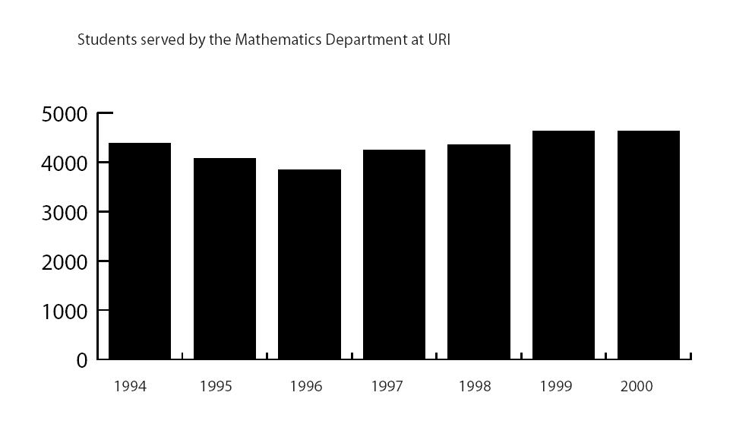

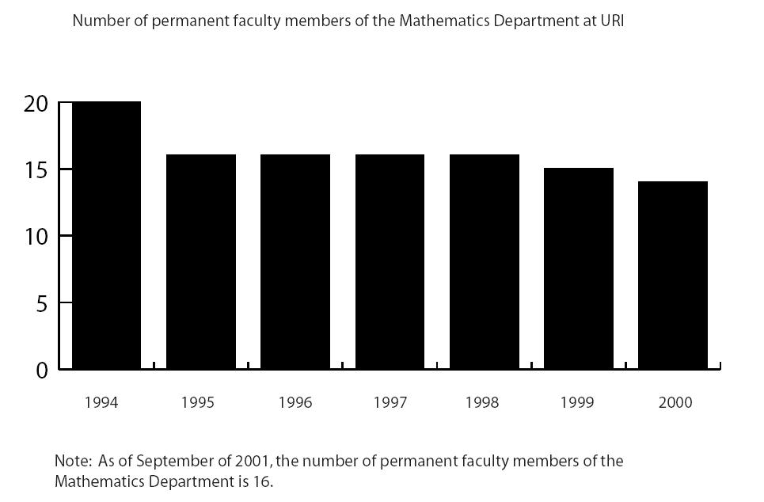

Department of Mathematics - URI

PhD Program Recent Graduates

Student Year Current Position/Employment
Rebecca Sparks | 2001 | Assistant Professor, Rhode Island College
Mary-Ann Saadi | 2001 | Assistant Professor, Fitchburg State College
Michael Arciero | 2001 | Visiting Assistant Professor, West Point Military Acad.
Michael Radin | 2001 | Assistant Professor, Rochester Inst. of Technology
Chris Teixeira | 2000 | Assistant Professor, Rhode Island College
Bill Briden | 2000 | Per-course Instructor, U. Rhode Island
Norman Prokup | 2000 | Rutgers Preparatory School
Mikhail Iakoubovski | 1999 | Davox Corporation
Adele Merrit | 1999 | National Security Agency
Scott Lewis | 1999 | Assistant Professor, Murray State College
Soudabeh Valicenti | 1999 | Per-course Instructor, U. Rhode Island
Jeff Feuer | 1998 | Assistant Professor, Coastal Carolina University
Amal Amleh | 1998 | Assistant Professor, U. Michigan at Dearborn.
Candace Kent | 1998 | Assistant Professor, Virginia Commonwealth Univ.
Kelly (Molkentin) Fuller | 1997 | Assistant Professor, Nazareth College
Richard Devault | 1997 | Assistant Professor, Northwestern State University
Tom Hull | 1997 | Assistant Professor, Merrimack College
Ali Farahani | 1996 | Assistant Professor, Fort Hays State University
George Tzanetopoulos | 1996 | University of Crete, Greece

Program Quality Review – Mathematics Dept.
Full-Time Faculty Survey

In response to a request from the Provost’s office to assess the quality of the Mathematics department this questionairre has been prepared to solicit your input. The responses will be entirely anonymous. If there are any questions, please contact any of the members of the committee, Prof. Ramdas Kumaresan (x44798), Prof. Steven Kay (x45804), Prof. Orlando Merino (x44442). Thanks in advance for your efforts.
Please circle a response for each question and feel free to add any comments.

1. How would you rate the quality of your undergraduate students?
Excellent Good Fair Poor

Comments ____________________________________________________________

2. How would you rate the quality of your graduate students?
Excellent Good Fair Poor

Comments ____________________________________________________________

3. How would you rate the appropriateness of your teaching load?
Excellent Good Fair Poor

Comments ____________________________________________________________

4. How would you rate the quality of your TAs?
Excellent Good Fair Poor

Comments ____________________________________________________________

5. How would you rate the opportunities for professional advancement, i.e, travel to meetings, exchange programs, sabbaticals, etc.?
Excellent Good Fair Poor

Comments ____________________________________________________________

6. How would you rate the University support?
Excellent Good Fair Poor

Comments ____________________________________________________________

7. How would you rate the physical plant, i.e, classrooms, meeting rooms, office, etc.?
Excellent Good Fair Poor

Comments ____________________________________________________________

8. How would you rate the library as a resource for research?
Excellent Good Fair Poor

Comments ____________________________________________________________

9. How would you rate the library as a resource for teaching?
Excellent Good Fair Poor

Comments ____________________________________________________________

10. How would you rate the quality of computer resources in general?
Excellent Good Fair Poor

Comments ____________________________________________________________

11. How would you rate the quality of the Academic Computer Center?
Excellent Good Fair Poor

Comments ____________________________________________________________

12. How would you rate the office/clerical support?
Excellent Good Fair Poor

Comments ____________________________________________________________

13. How would you rate the collegiality of the department?
Excellent Good Fair Poor

Comments ____________________________________________________________

14. How would you rate the ability to hire and retain faculty members?
Excellent Good Fair Poor

Comments ____________________________________________________________

15. How would you rate the diversity/affirmative action efforts?
Excellent Good Fair Poor

Comments ____________________________________________________________

Please comment on the following:
1. Strengths of the department
____________________________________________________________________
_____________________________________________________________________
____________________________________________________________________

2. Weaknesses of the department
____________________________________________________________________
____________________________________________________________________
_____________________________________________________________________

3. Suggestions for improvement
____________________________________________________________________
____________________________________________________________________
_____________________________________________________________________

4. Is the department improving, declining or just maintaining itself?

____________________________________________________________________
____________________________________________________________________
_____________________________________________________________________

5. Most pressing departmental need

____________________________________________________________________
____________________________________________________________________
_____________________________________________________________________

Program Quality Review – Mathematics Dept.
Student Survey for Mathematics Majors

In response to a request from the Provost’s office to assess the quality of the Mathematics department this questionnaire has been prepared to solicit your input. The responses will be entirely anonymous. If there are any questions, please contact any of the members of the committee, Prof. Ramdas Kumaresan (x44798), Prof. Steven Kay (x45804), Prof. Orlando Merino (x44442). Thanks in advance for your efforts.
Please circle a response for each question and feel free to add any comments.

1. How would you rate the quality of your Math. course instructors?
Excellent Good Fair Poor

Comments ____________________________________________________________

2. How would you rate the accessibility of your Math. course instructors?
Excellent Good Fair Poor

Comments ____________________________________________________________

3. How would you rate the quality of the Math. TAs?
Excellent Good Fair Poor

Comments ____________________________________________________________

4. How would you rate the accessibility of the Math. TAs?
Excellent Good Fair Poor

Comments ____________________________________________________________

5. How would you rate the quality of the Math. departmental faculty?
Excellent Good Fair Poor

Comments ____________________________________________________________

6. How would you rate the quality of your Math. academic advisor?
Excellent Good Fair Poor

Comments ____________________________________________________________

7. How would you rate the course load required for your degree?
Excellent Good Fair Poor

Comments ____________________________________________________________

8. How would you rate the academic support, i.e., instructors, tutors, etc.?
Excellent Good Fair Poor

Comments ____________________________________________________________

9. How would you rate the physical plant, i.e., classrooms, meeting rooms, etc.?
Excellent Good Fair Poor

Comments ____________________________________________________________

10. How would you rate the computer resources?
Excellent Good Fair Poor

Comments ____________________________________________________________

11. How would you rate the quality of the library?
Excellent Good Fair Poor

Comments ____________________________________________________________

12. How would you rate the relevance of the program to your future goals?
Excellent Good Fair Poor

Comments ____________________________________________________________

13. How would you rate the opportunities for undergraduate involvement in research?
Excellent Good Fair Poor

Comments ____________________________________________________________

14. How would you rate the quality of diversity/ affirmative action efforts?
Excellent Good Fair Poor

Comments ____________________________________________________________

15. How would you rate your overall experience at URI?
Excellent Good Fair Poor

Comments ____________________________________________________________

Please comment on the following:
1. Strengths of the department
____________________________________________________________________
_____________________________________________________________________
____________________________________________________________________

2. Weaknesses of the department
____________________________________________________________________
____________________________________________________________________
_____________________________________________________________________

3. Suggestions for improvement
____________________________________________________________________
____________________________________________________________________
_____________________________________________________________________

4. Most pressing need

____________________________________________________________________
____________________________________________________________________
_____________________________________________________________________

